Problem Set 3 Report

Part 1: Backward Iteration

When we plot the value function for retirees, we see that their value function is increasing and concave. In terms of the savings decisions for a worker at age 20, the plot depends on both z (productivity) and a (current asset level). For high productivity individuals, savings is decreasing in current asset level until a point, then the line slopes upward. For low productivity individuals, savings is generally increasing in current asset level. For both workers, savings drops quickly past a high level of current asset level.

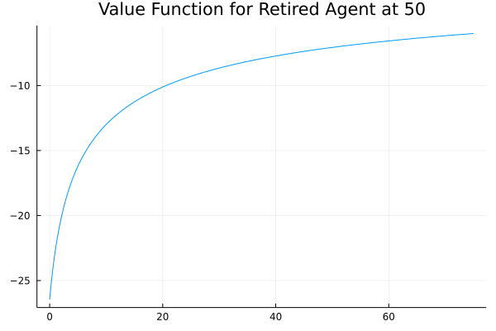

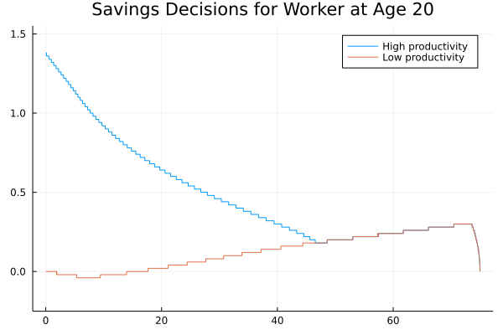

Part 2: Solving for stationary distribution

Please see the attached code for the program that solves the stationary distribution.

Part 3: Benchmark Model and Counterfactual Experiments

|  |  |  |  |  |  |  |
| --- | --- | --- | --- | --- | --- | --- |
| Parameter/Result | BM | BM + No SS | No risk | No risk + No SS | Exog. LS | Exog. LS + No SS |
| theta | 0.11 | 0 | 0.11 | 0 | 0.11 | 0 |
| z_h | 3.0 | 3.0 | 0.5 | 0.5 | 3.0 | 3.0 |
| gamma | 0.42 | 0.42 | 0.42 | 0.42 | 1 | 1 |
| K | 3.3589 | 4.6035 | 1.0453 | 1.2878 | 7.3598 | 10.4539 |
| L | 0.3432 | 0.3652 | 0.1600 | 0.1682 | 0.7543 | 0.7543 |
| w | 1.4548 | 1.5936 | 1.2578 | 1.3317 | 1.4533 | 1.6490 |
| r | 0.0236 | 0.011 | 0.0483 | 0.0379 | 0.0238 | 0.0069 |
| b | 0.2251 | 0 | 0.0908 | 0 | 0.4942 | 0 |
| welfare | -35.768 | -37.382 | -45.066 | -45.157 | -23.003 | -25.758 |
| cv(wealth) | 1.5298 | 1.3983 | 0.6627 | 0.7603 | 1.5101 | 1.3243 |
| iterations | 11 | 6 | 11 | 12 | 9 | 3 |
| time | 550 sec | 307 sec | 461 sec | 526 sec | 387 sec | 127 sec |
| lambda | 0.99 | 0.99 | 0.3 | 0.3 | 0.99 | 0.99 |
| tolerance | 1e-3 | 1e-3 | 1e-2 | 1e-2 | 1e-3 | 1e-3 |
| Initial K, L | (3.3, 0.3) | (3.3, 0.3) | (1.0, 0.1) | (1.0,0.1) | (3.0, 0.3) | (3.0, 0.3) |

Benchmark model with social security: The interest rate is 2.36% in this specification. The growth rate is around 1.1%.

* Is this economy dynamically efficient?

Benchmark model without social security: When social security is eliminated, we see that aggregate capital and labor supply both increase. This makes intuitive sense, since workers have to work more and save, in order to have enough assets saved for consumption when they are retired.

* How does aggregate welfare change?
* Who benefits and loses from the reform?
* How does the reform affect cross sectional wealth inequality?

No idiosyncratic risk with/without social security: In this specification, we set the high productivity to the same rate as low productivity, so there’s no idiosyncratic shocks to productivity.

* How does aggregate capital stock change relative to benchmark?
* How does aggregate welfare change when social security is eliminated?

Exogenous labor supply with/without social security